Creating a database and tables named sample and salesman, customer and orders respectively

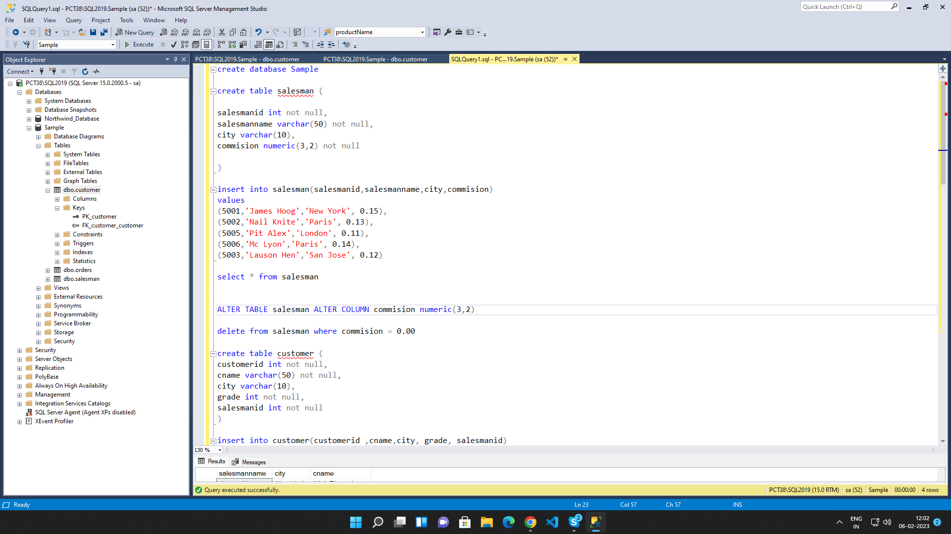

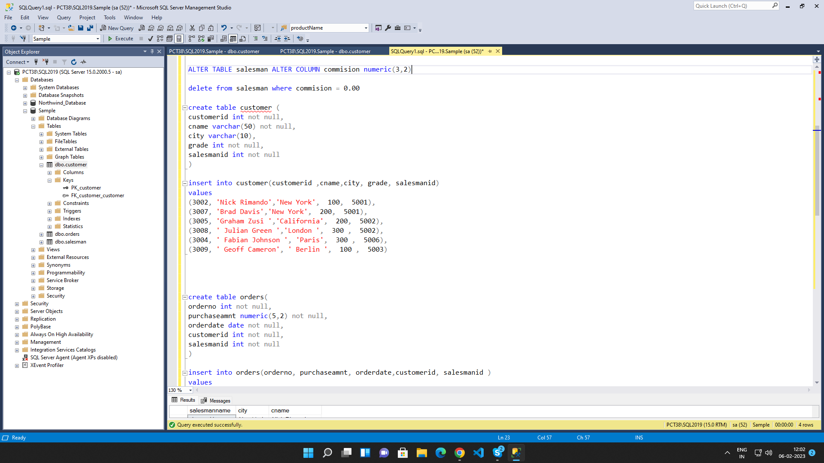

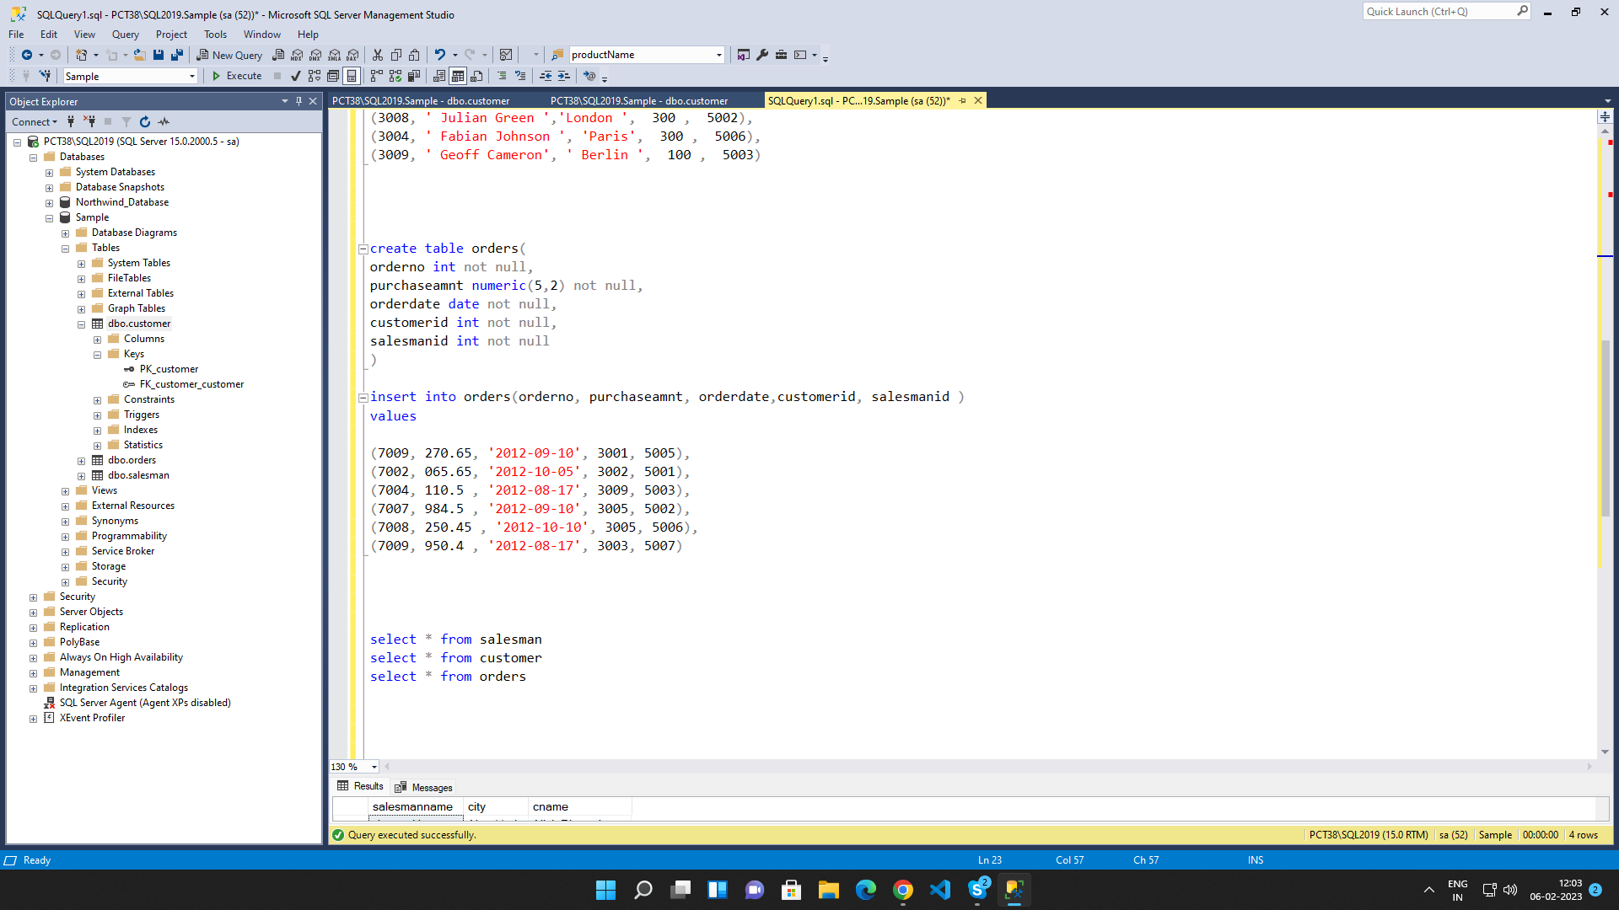

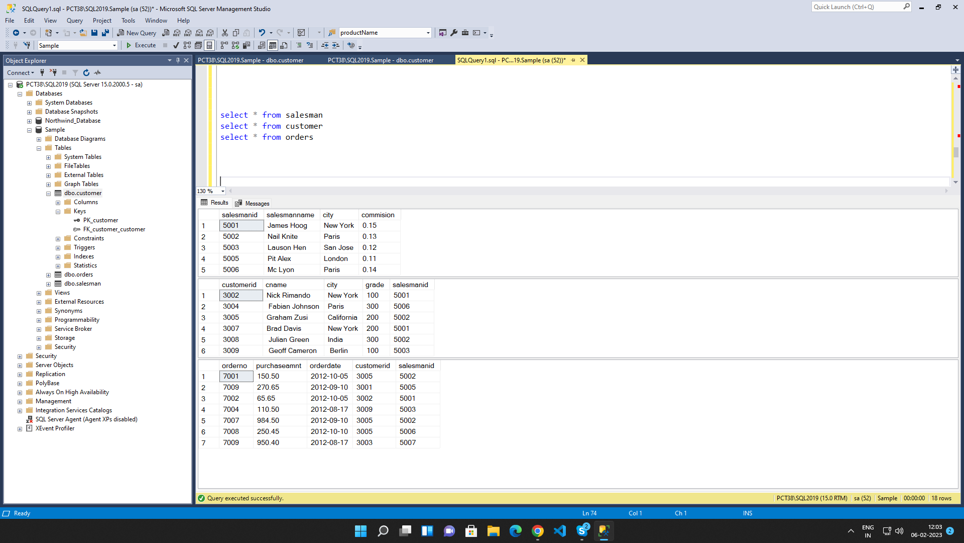

1. write a SQL query to find the salesperson and customer who reside in the same city.
Return Salesman, cust_name and city

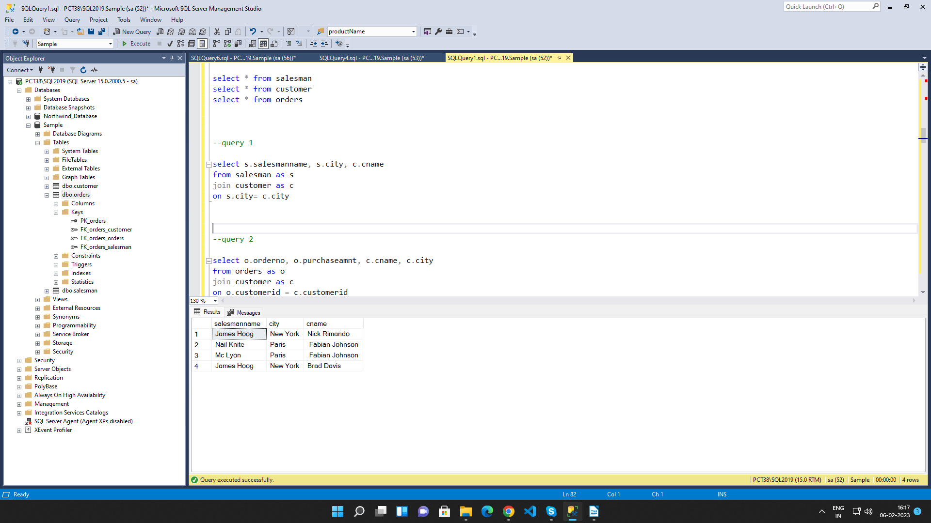

2. write a SQL query to find those orders where the order amount exists between 500
and 2000. Return ord_no, purch_amt, cust_name, city

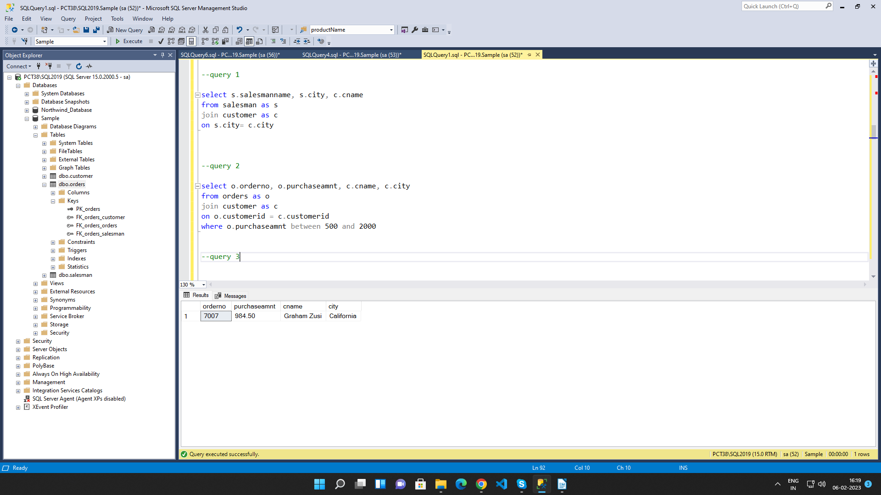

3. write a SQL query to find the salesperson(s) and the customer(s) he represents.
Return Customer Name, city, Salesman, commission

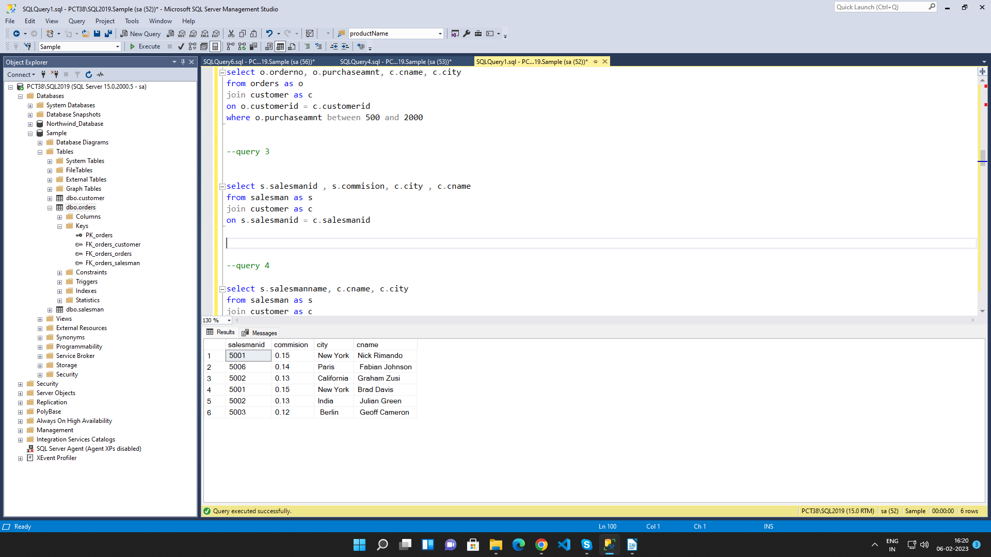

4. write a SQL query to find salespeople who received commissions of more than 12
percent from the company. Return Customer Name, customer city, Salesman,
commission.

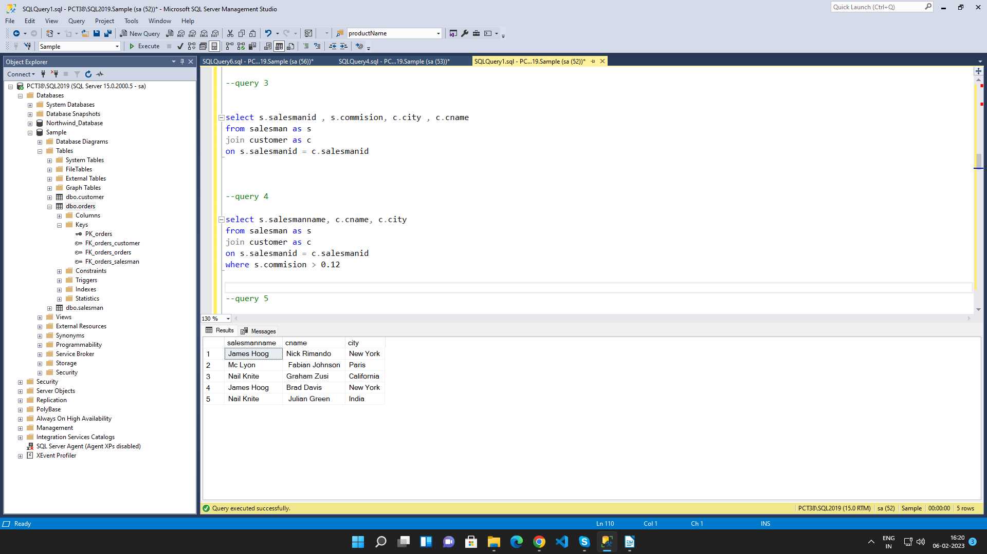
5. write a SQL query to locate those salespeople who do not live in the same city where
their customers live and have received a commission of more than 12% from the
company. Return Customer Name, customer city, Salesman, salesman city,
commission

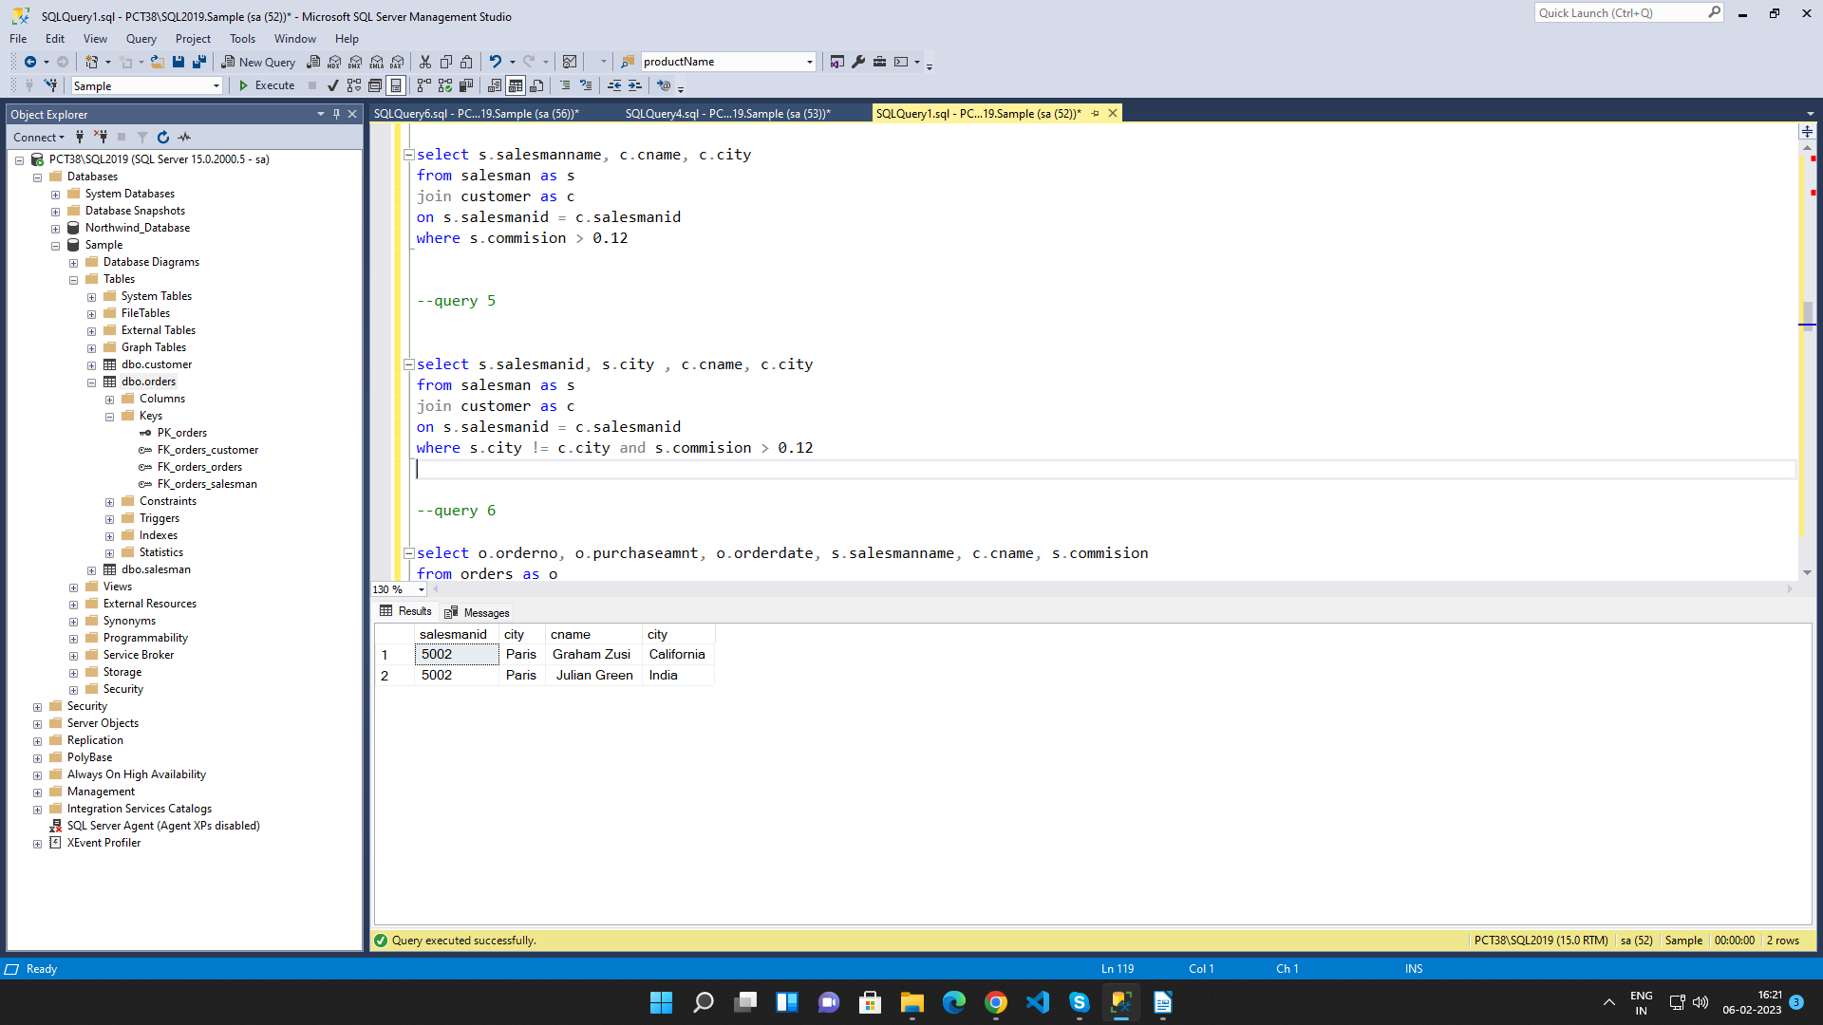

6. write a SQL query to find the details of an order. Return ord_no, ord_date,
purch_amt, Customer Name, grade, Salesman, commission

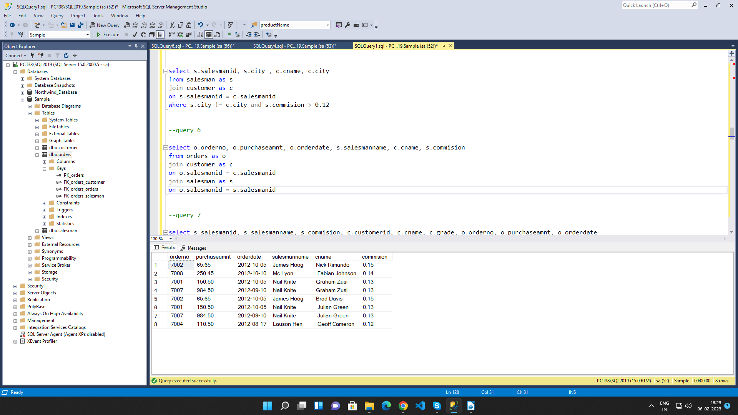

7. Write a SQL statement to join the tables salesman, customer and orders so that the
same column of each table appears once and only the relational rows are returned.

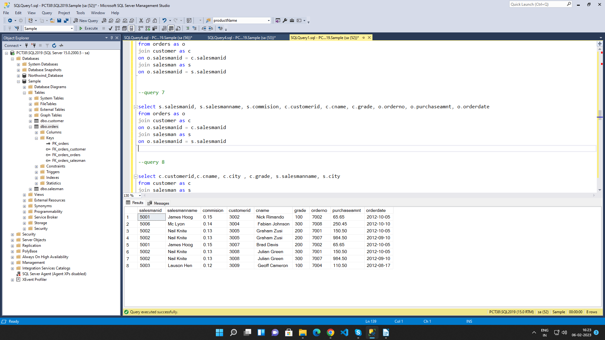

8. write a SQL query to display the customer name, customer city, grade, salesman,
salesman city. The results should be sorted by ascending customer_id.

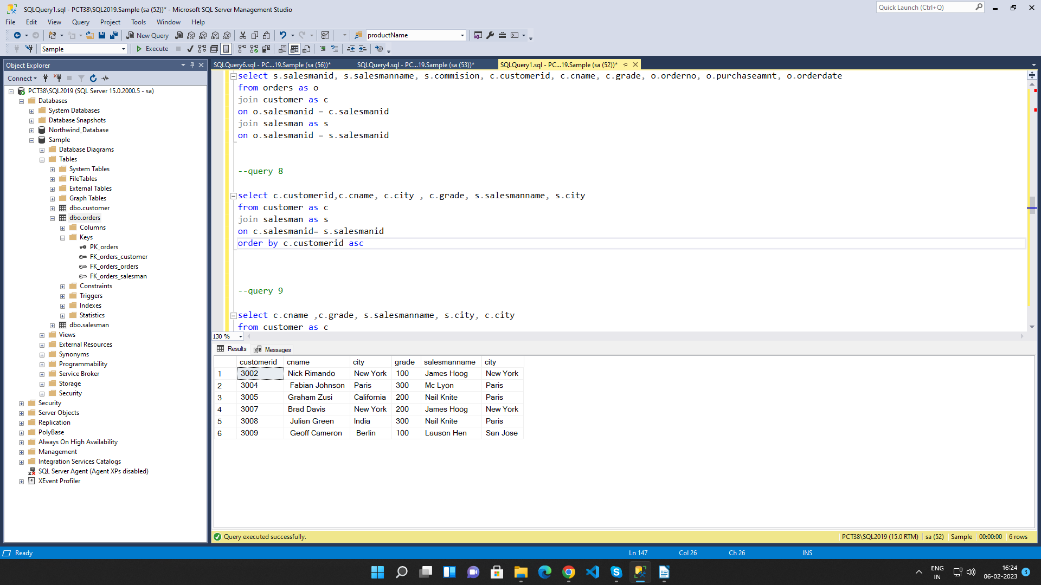

9. write a SQL query to find those customers with a grade less than 300. Return
cust_name, customer city, grade, Salesman, salesmancity. The result should be
ordered by ascending customer_id.

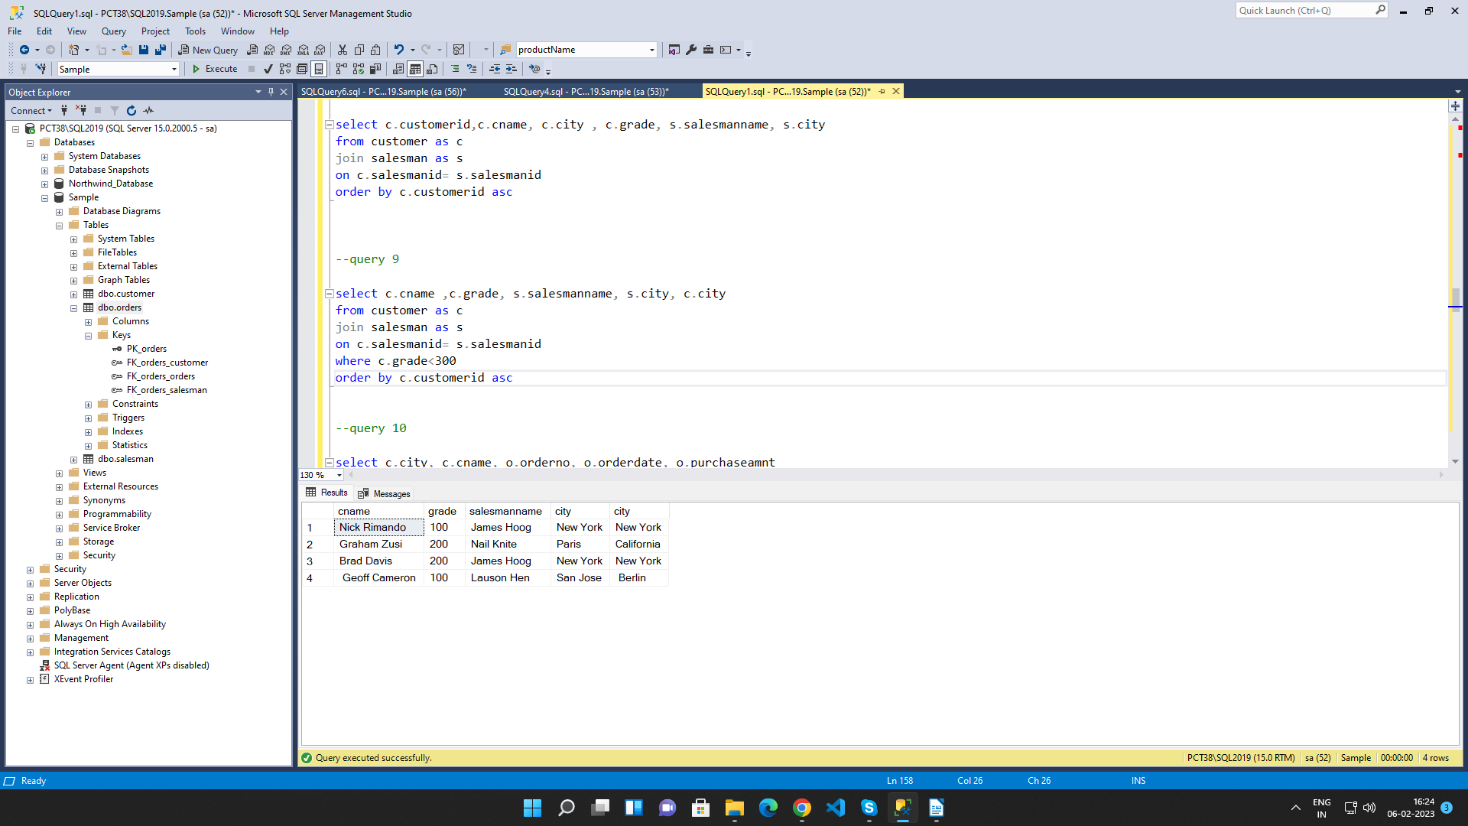

10. Write a SQL statement to make a report with customer name, city, order number,
order date, and order amount in ascending order according to the order date to
determine whether any of the existing customers have placed an order or not

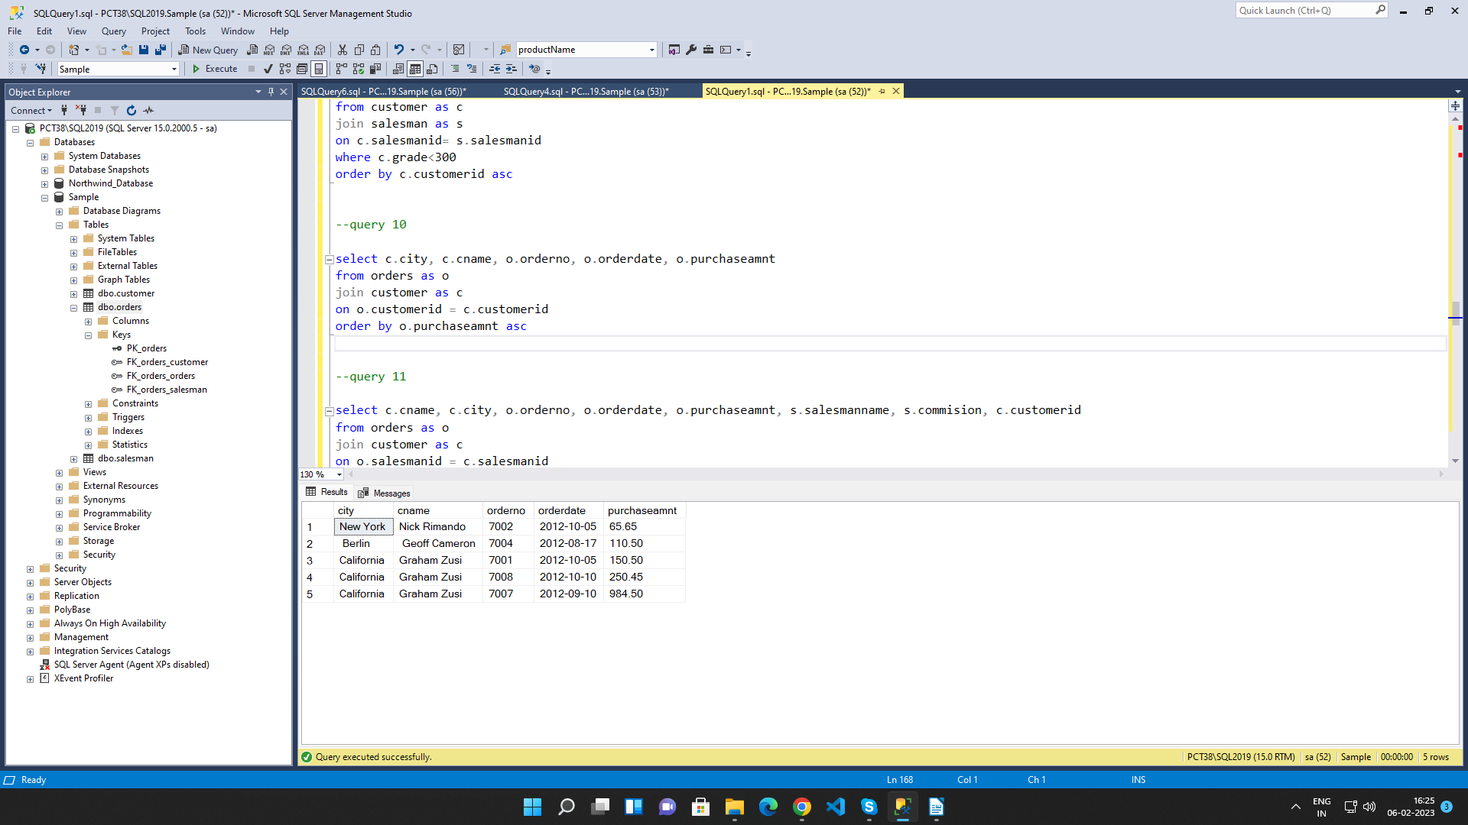

11. Write a SQL statement to generate a report with customer name, city, order number,
order date, order amount, salesperson name, and commission to determine if any of
the existing customers have not placed orders or if they have placed orders through
their salesman or by themselves

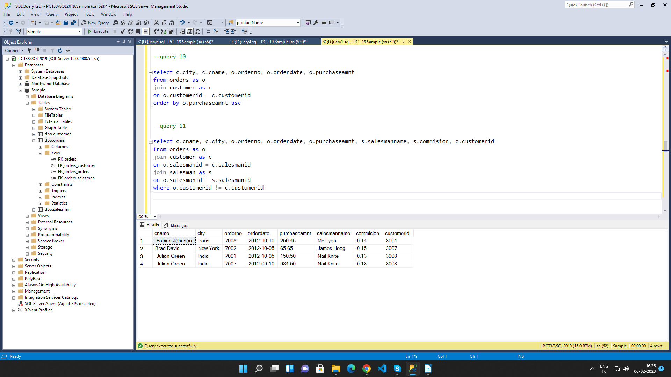

12. Write a SQL statement to generate a list in ascending order of salespersons who
work either for one or more customers or have not yet joined any of the customers

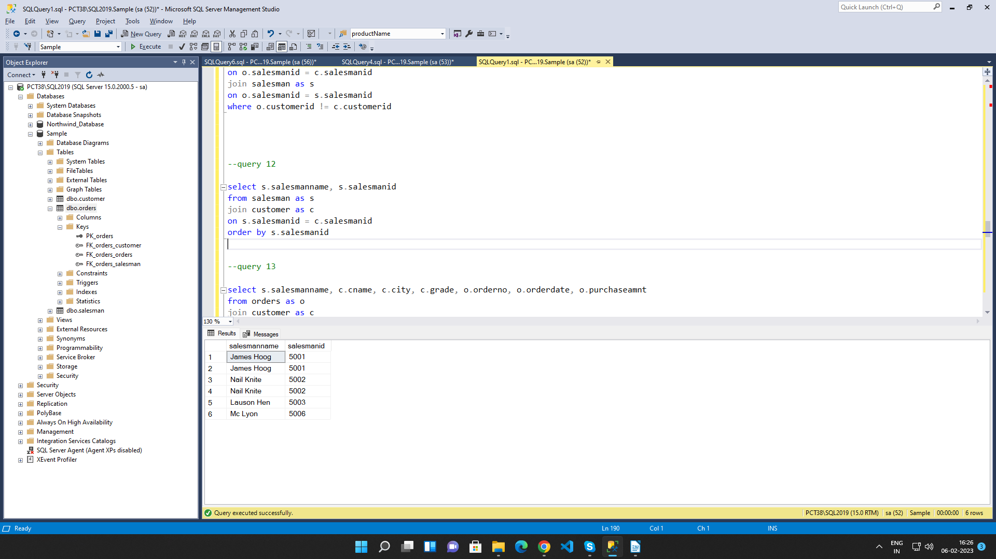

13. write a SQL query to list all salespersons along with customer name, city, grade,
order number, date, and amount.

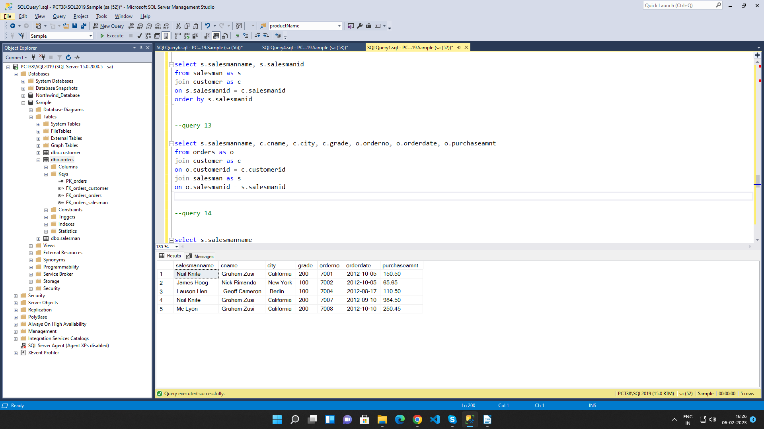

14. Write a SQL statement to make a list for the salesmen who either work for one or
more customers or yet to join any of the customers. The customer may have placed,
either one or more orders on or above order amount 2000 and must have a grade, or
he may not have placed any order to the associated supplier.

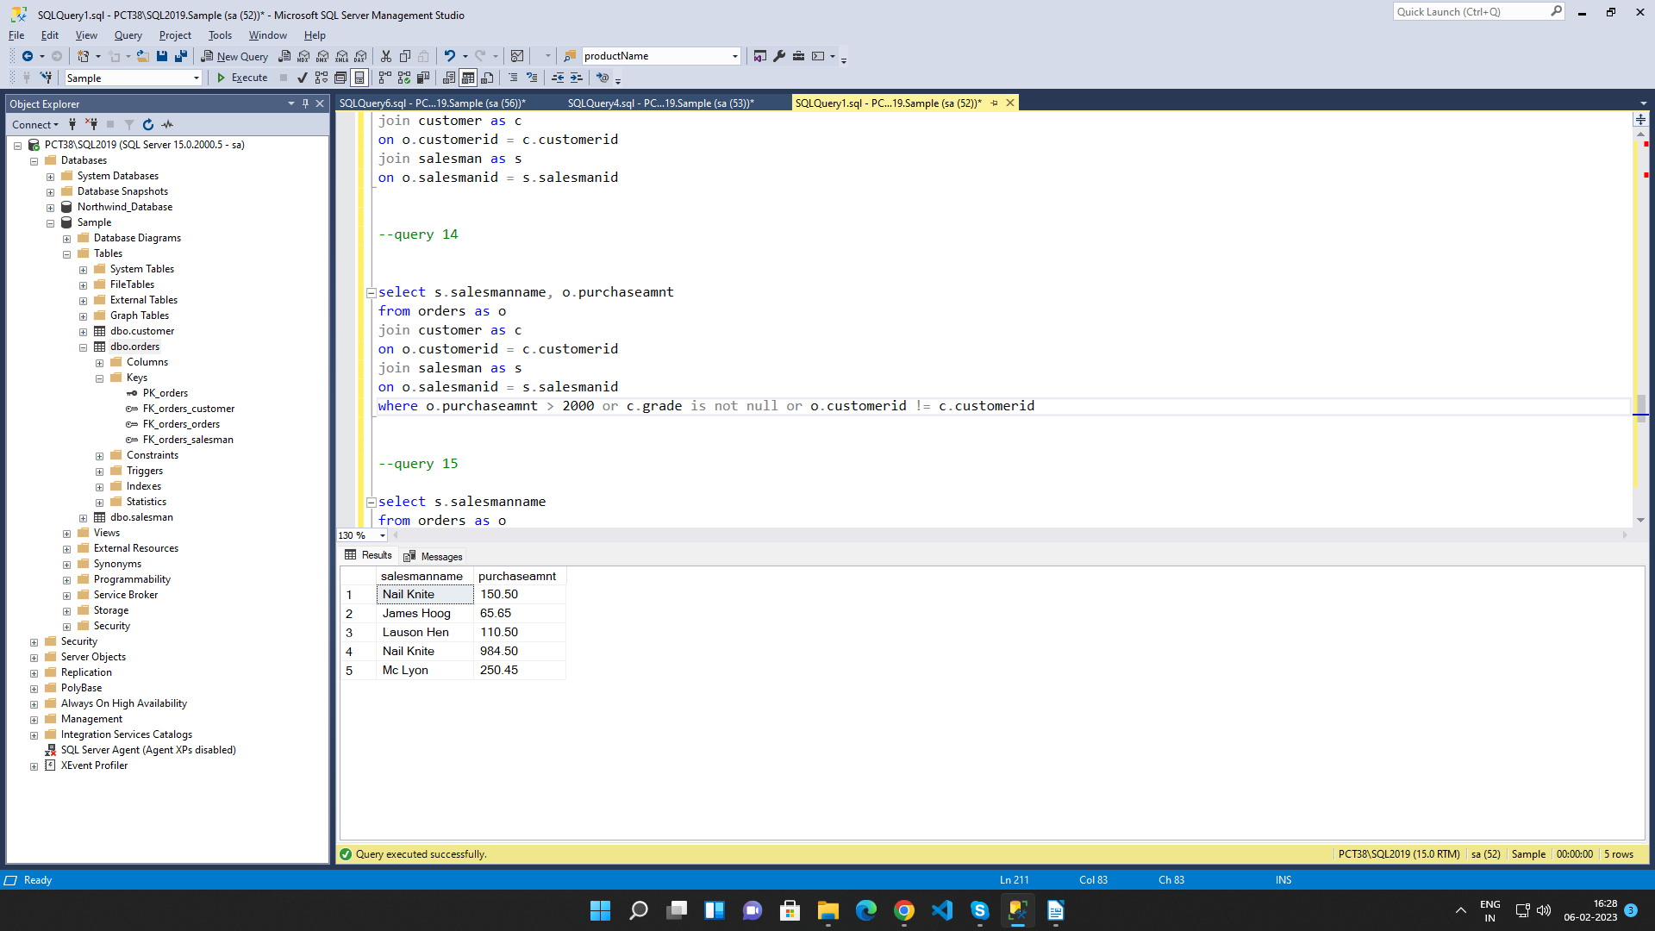

15. Write a SQL statement to generate a list of all the salesmen who either work for one
or more customers or have yet to join any of them. The customer may have placed
one or more orders at or above order amount 2000, and must have a grade, or he
may not have placed any orders to the associated supplier.

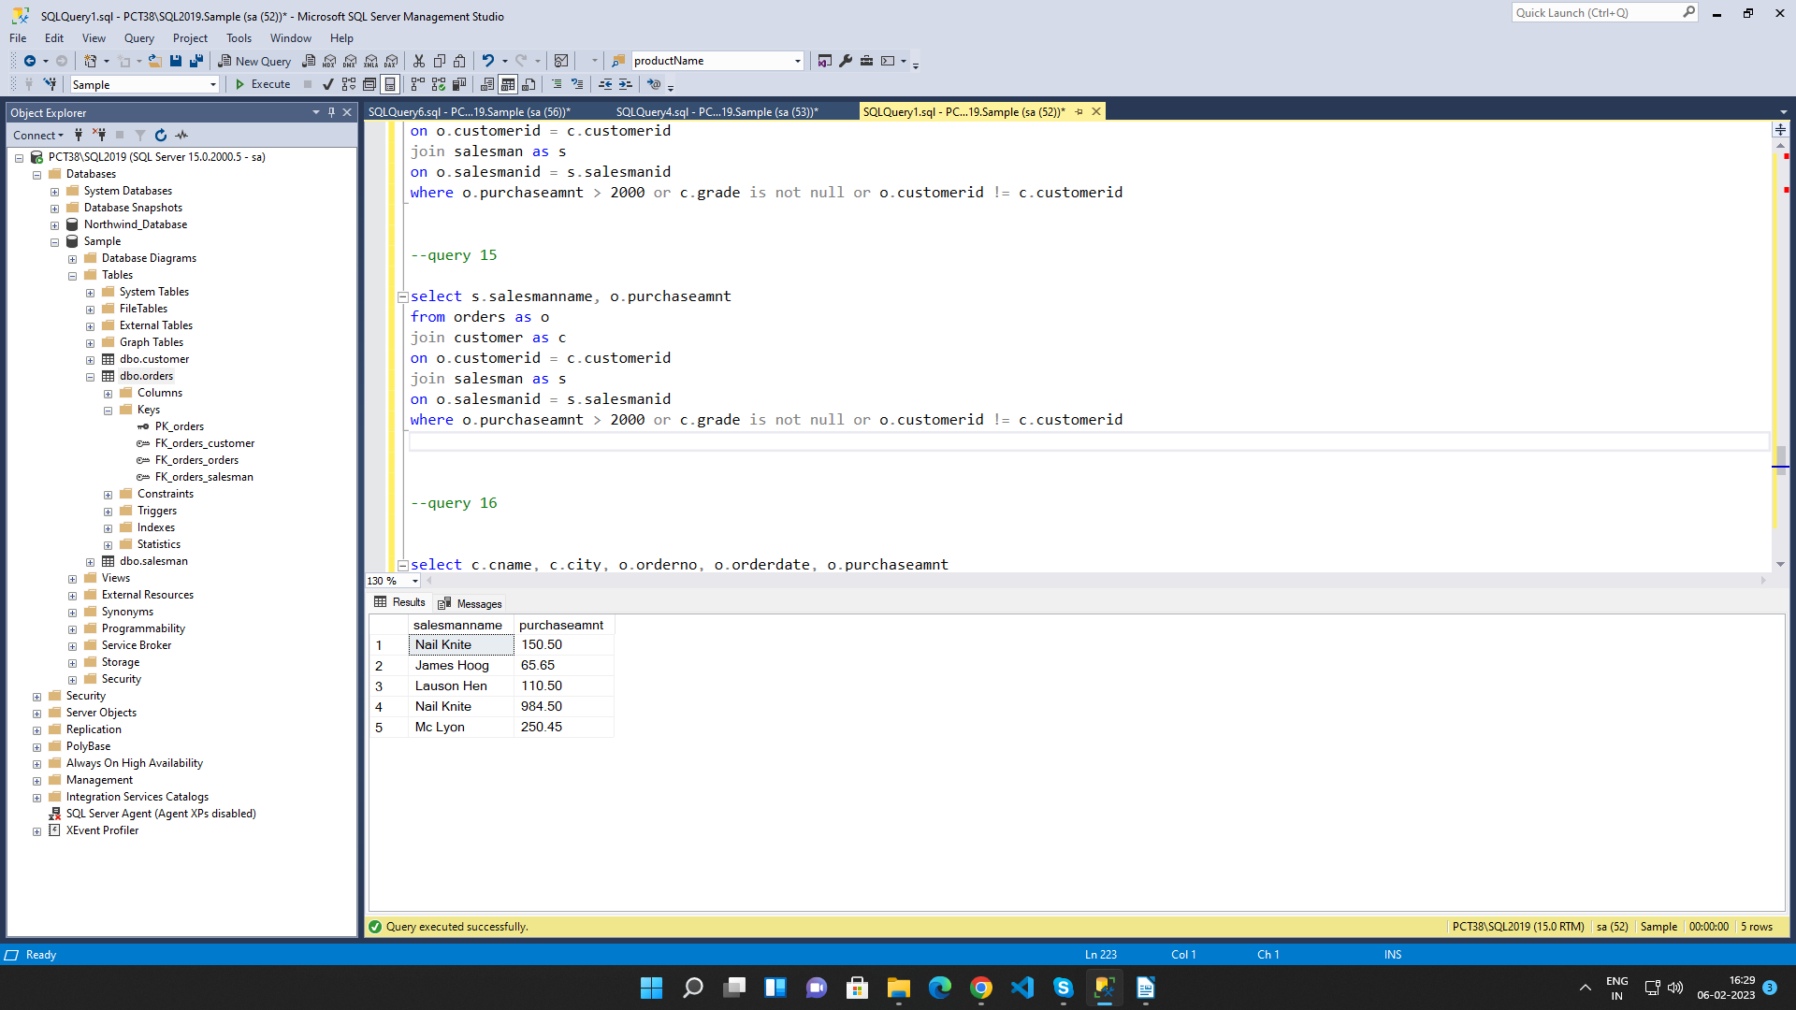

16. Write a SQL statement to generate a report with the customer name, city, order no.
order date, purchase amount for only those customers on the list who must have a
grade and placed one or more orders or which order(s) have been placed by the
customer who neither is on the list nor has a grade.

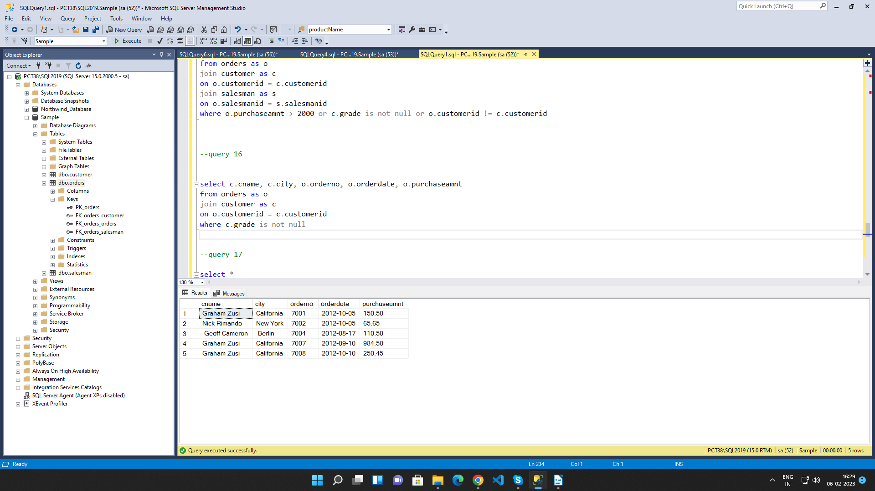

17. Write a SQL query to combine each row of the salesman table with each row of the
customer table

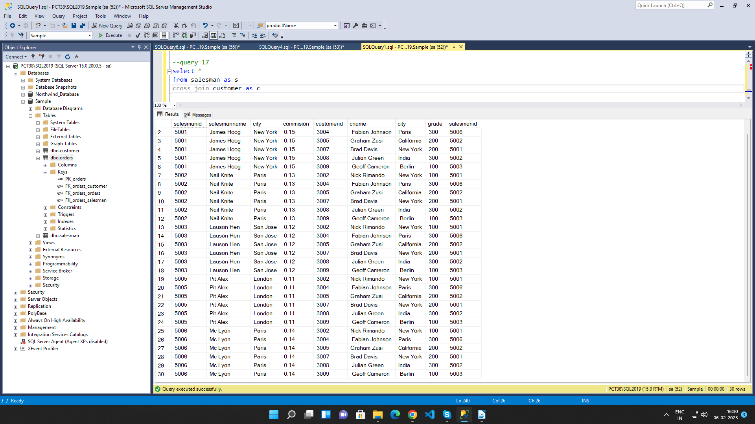

18. Write a SQL statement to create a Cartesian product between salesperson and
customer, i.e. each salesperson will appear for all customers and vice versa for that
salesperson who belongs to that city

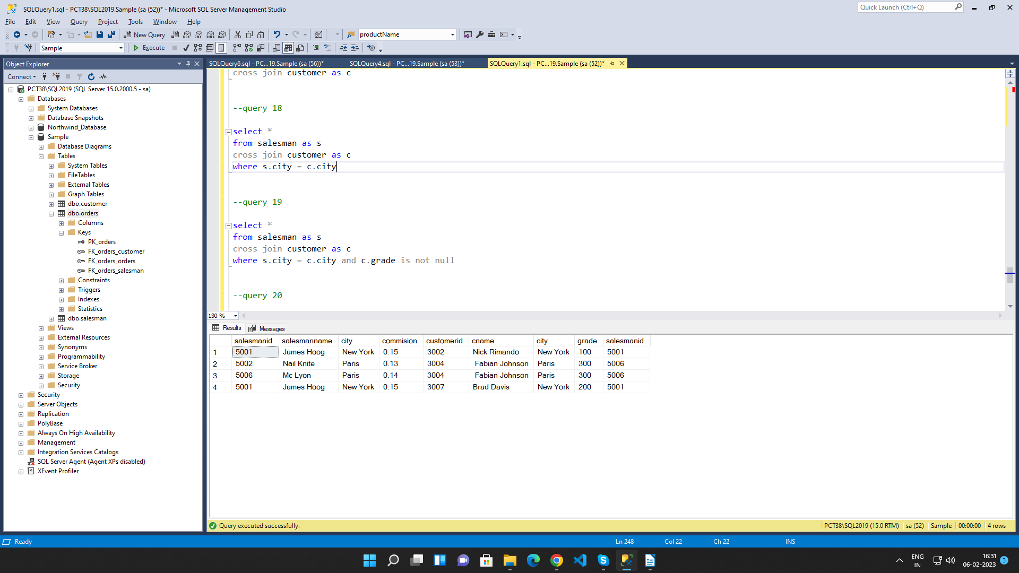

19. Write a SQL statement to create a Cartesian product between salesperson and
customer, i.e. each salesperson will appear for every customer and vice versa for
those salesmen who belong to a city and customers who require a grade

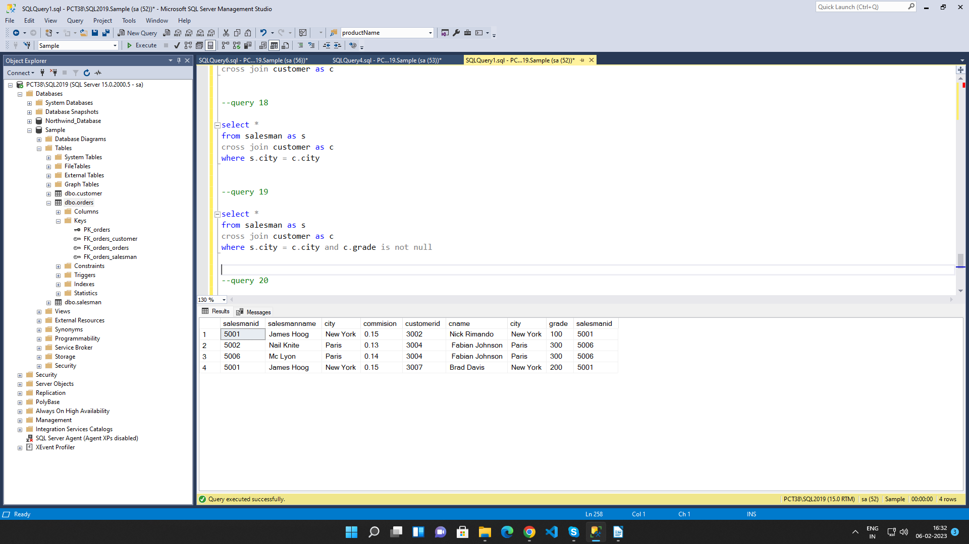

20. Write a SQL statement to make a Cartesian product between salesman and
customer i.e. each salesman will appear for all customers and vice versa for those
salesmen who must belong to a city which is not the same as his customer and the
customers should have their own grade



